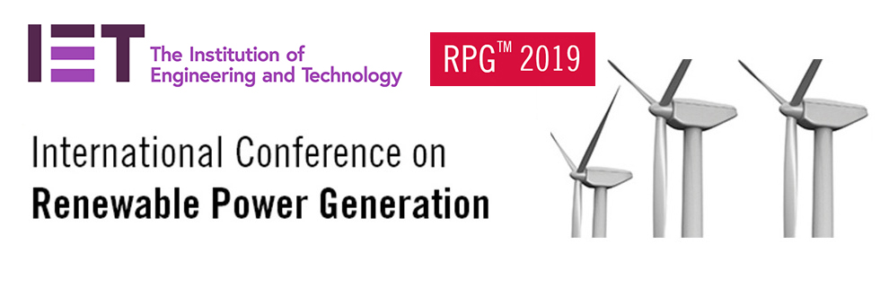
FAQ for RPG 2019 authors
常见问题
If you need to revise your full paper
如果您需要修改文章
- Authors are allowed to make small revisions after their paper being accepted (such as small revision on title, adding/removing authors, change affiliations, correct language and formatting mistakes, polish English language and technical expressions).
文章被接收后，作者可以对文章进行微调（例如修改题目，添加或减少作者，修改单位信息，修改语言及格式错误，对英语语言进行润色及对技术语言进行修改等）

- Major changes are not allowed (such as adding/removing large chunks of text, change the subject significantly, change the title and theme of the paper completely)
文章被接收后不允许做主体改动（例如增减大段文字，完全改变文章内容/研究方向/题目等）

- iThenticate check will be actioned again after the conference and before publication using the FINAL version of the paper. IET reserves the right to make decision whether a paper can be accepted.
会议结束后，文章出版前，所有文章会使用最终稿件进行二次查重。IET保留在任何阶段对文章是否符合出版要求，是否允许出版做出决定的权利

- Please make sure the information in the final full paper and the information in the submission system matches each other otherwise it may cause issue as all the data are extracted from the system.
请确保投稿系统内的文章信息与最终全文内信息保持一致，以免数据导出后不一致影响您文章的正常出版。

- All revision must be completed before 23 Aug 2019. RPG committee cannot guarantee any information submitted later than this date be published at the final proceeding.
所有修改必须在2019年8月23日之前通过投稿系统修改。RPG组委会无法保证在该日期之后提交的信息会被会议论文集采用。

How can I register & make payment
如何注册缴费
- Registration must be done via the RPG 2019 website
参会注册需通过RPG官网提交

- At least 1 author must register & attend the conference to present the paper
每篇文章必须有至少一名作者注册参会及对文章进行报告

- The different registration category can be found here. Whoever attends the conference should make the registration and payment based on the category that suite him/her best.
注册类型请参考会议网站。注册原则为谁参会--谁注册--谁缴费。

- Payment should be made via bank transfer or Alipay. Paper ID and SN code should be added as a note when transferring/uploading your payment confirmation sheet. If the website status display unpaid, please wait patiently, we need 1-2 working days to confirm the public transfer.
可通过银行转账或支付宝付款。请在转账时填写文章号及注册后得到的SN号并上传支付宝付款截图或银行转账确认单，若网站状态显示未付款unpaid请耐心等候，对公转账我方需1-2个工作日确认）
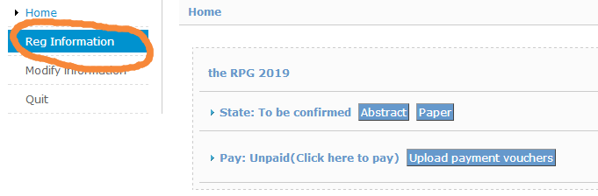
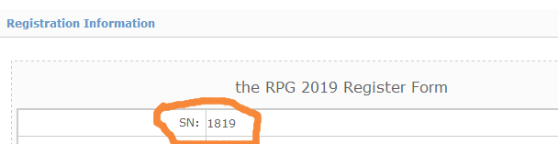

- Single one author attend/present 2 or more paper, the 2nd or the 3rd paper are Additional paper and are entitled for a discount.
一位作者参会报告2-3篇文章，第二篇及第三篇稿件可作为额外文章享受折扣。不同作者参会报告不同文章不能使用该折扣

Request for an Acceptance letter or Invoice
申请录用通知及发票
- After completing the registration and payment process, should you need an acceptance letter please send your SN number and paper ID to event@theiet.org.cn to request for an electronic copy of acceptance letter.
若您需要录用通知，请在注册及付款后，发送您的SN号及文章号到IET会议邮箱我们会有同事为您提供电子版录用通知

- One of the IET staff will contact you to submit information for invoice/fapiao later. Invoice/fapiao can be collected on-site during the conference or sent to you via SF delivery (cost covered by receiver)
在确认付款成功后，IET员工会主动与您取得联系并协助您办理发票。发票通常在开会期间领取，若您希望提前拿到发票，我们可以顺丰到付给您，请提前向IET工作人员说明。

Presentation format and event programme
报告形式及会议日程
- Presentation format is decided by the technical committee of RPG 2019 conference to suit the event programme and balance the presentation theme. We will try to accommodate your preference but unfortunately it cannot be guaranteed.
文章报告形式由技术委员会根据会议日程及论坛主题决定，我们会尽量协调您的选择但很抱歉不能保证满足您的要求。
其他问题欢迎联系我们：
Event General Enquiries
Ann An
Event Assistant
Tel: +86 (0)10 6566 4687 ext 108
Email: vwan@theiet.org

Event collaboration & Business Development
Ting Ting Liu
Event Manager
Tel: +86 (0)10 6566 4687 ext 222
Email: tliu@theiet.org
Media enquiries
Joyce Zhu
Marcomm Manager
Tel: +86 (0)10 6566 4687 ext 107
Email: jzhu@theiet.org

